Bio-synthetic Fur

Market Intervention

Illustration 产品概览

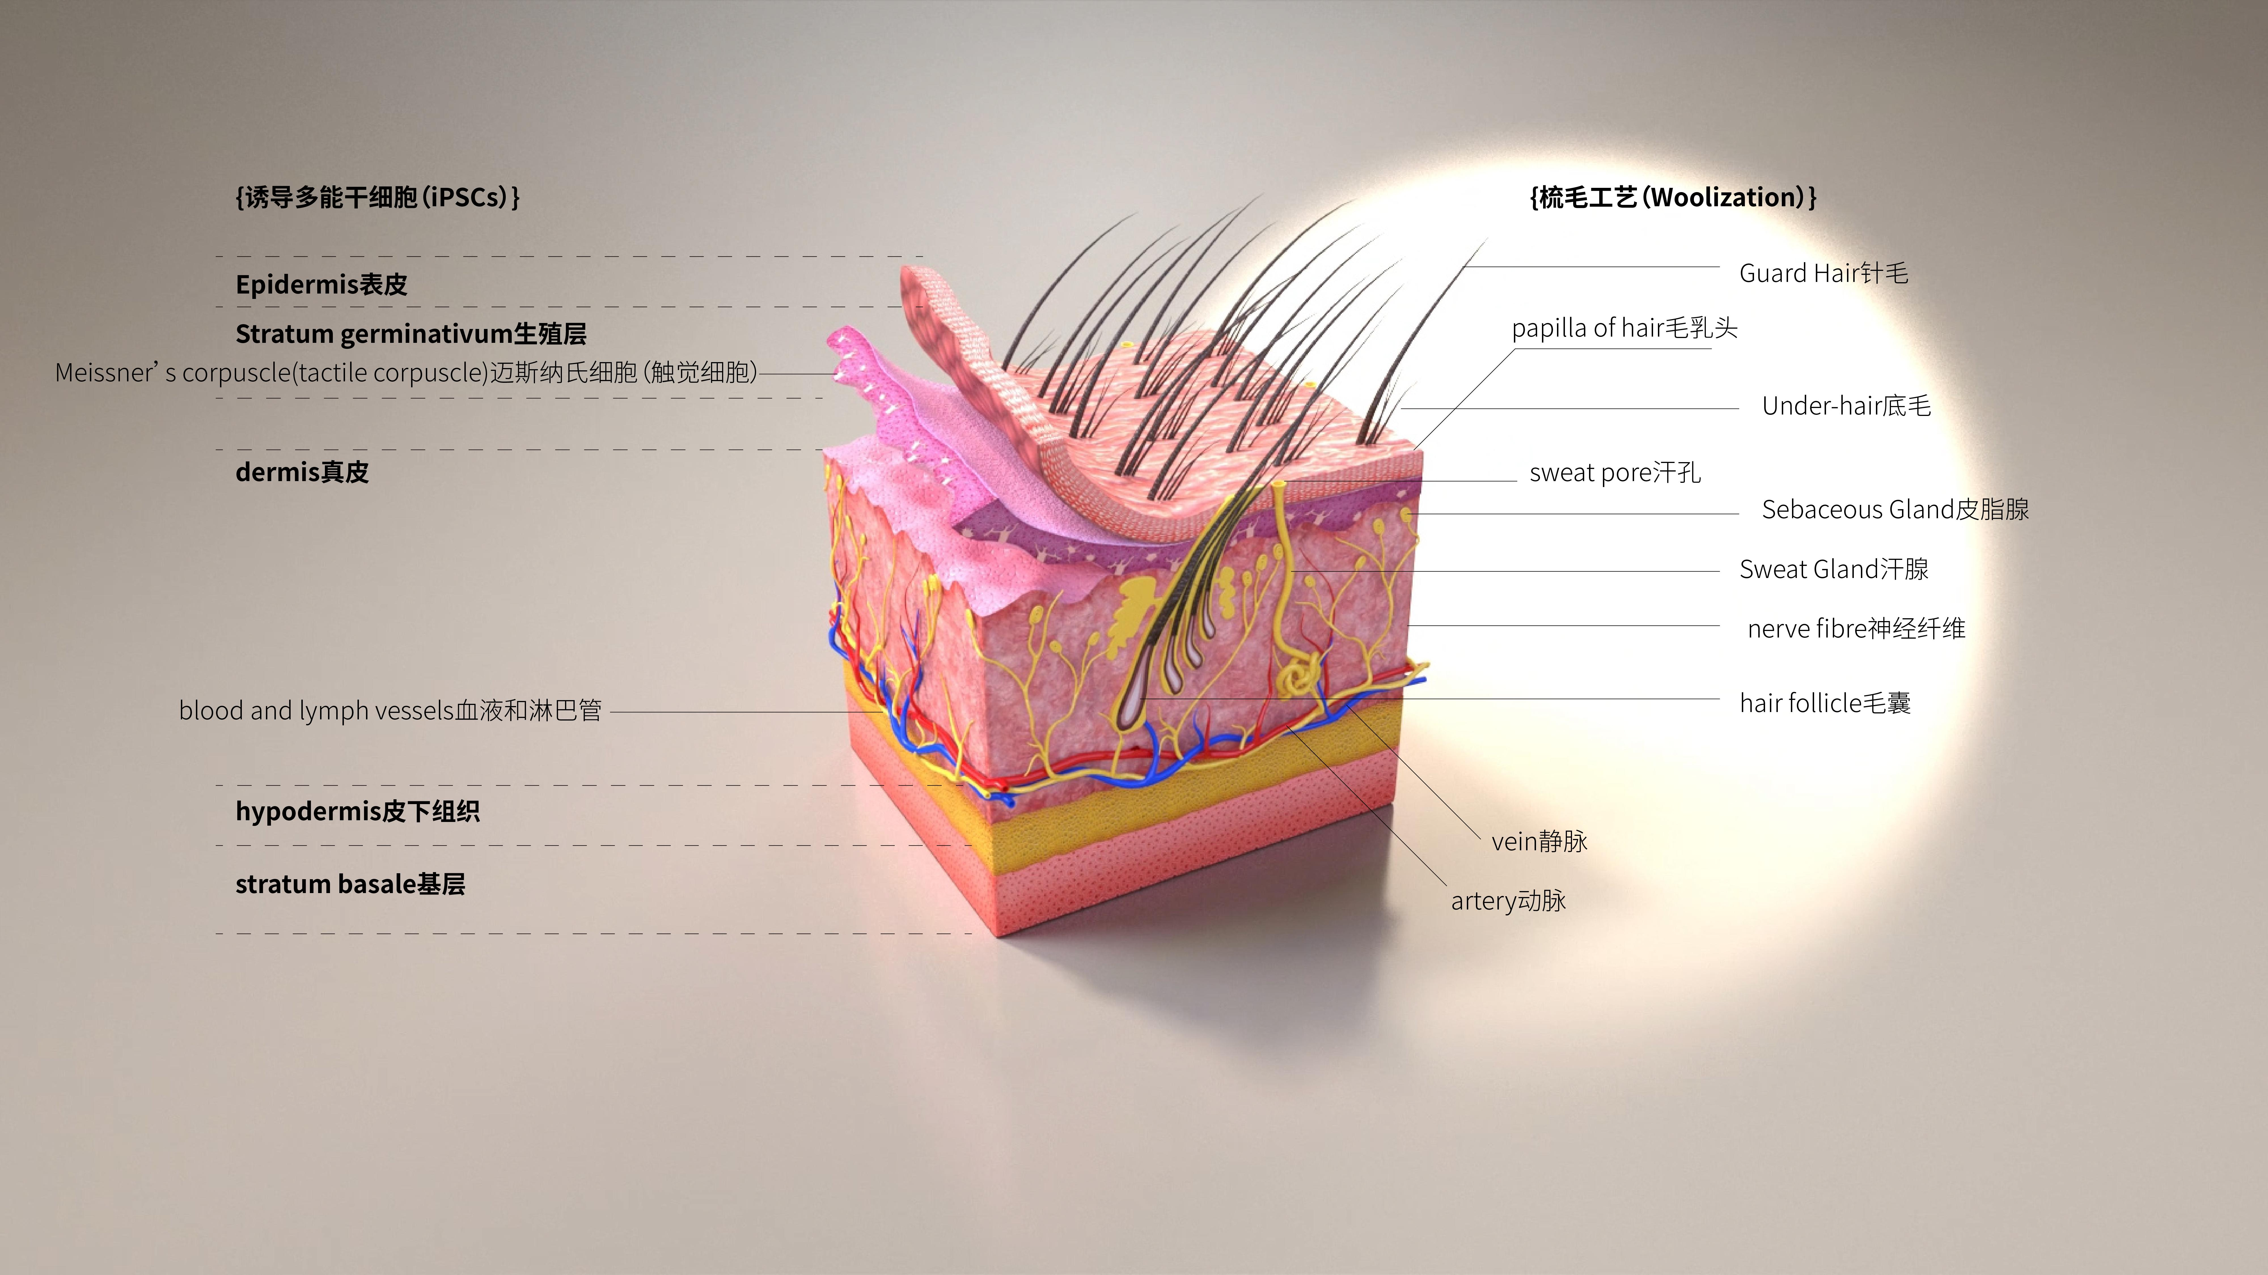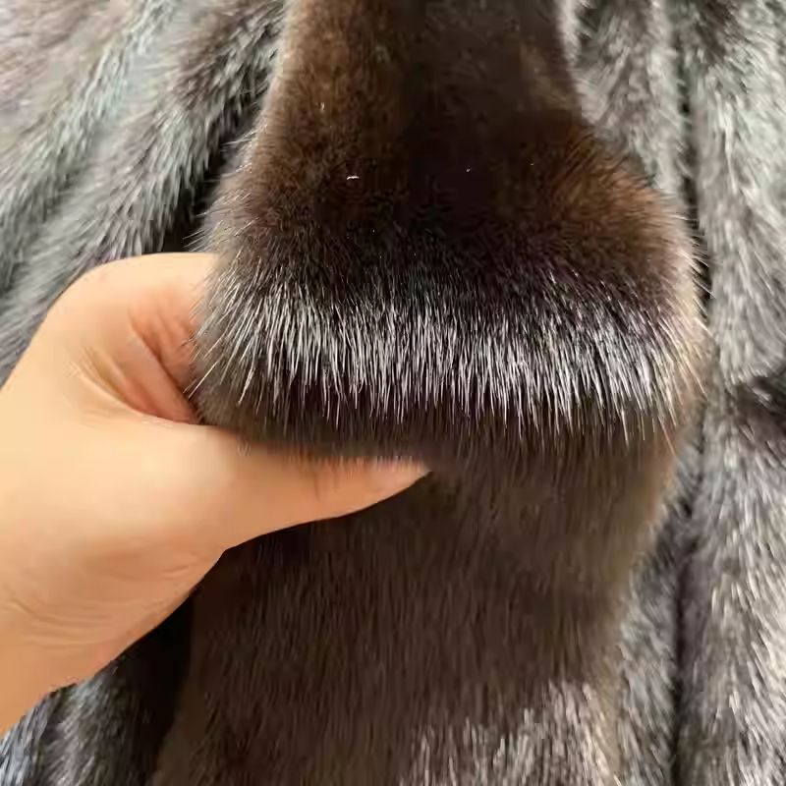

This is a mink fur, however, it is not obtained from mink, instead it is a laboratory synthesis. 这是一张特殊的水貂皮，它不是从动物身上获取而是通过实验室生物合成的。

1. What is your occupation/background? 您的职业/背景？
2. Will you accept fur in this form? 您会接受这种形式的皮草吗？

A. YES 会

B. NO(Reason) 不会（原因）:

1. How much extra are you willing to pay for this kind of product? (Genuine mink garments are known to sell for $1000 average) 您会愿意为这种全新的皮草承担多少溢价？（已知真皮成衣的销售均价在1000美金）

A. No premiums accepted for fake fur 不愿意为假毛承担任何溢价

B. Equivalent price accepted（+-10%）愿意承担与真皮相符的售价

C. Slight premium accepted(+15%) 愿意承担轻微的溢价

D. Any price accepted 愿意承担任何的溢价

|  |  |
| --- | --- |
| Tip备注 |  |