Business Plan

of

Bio-synthetic Fur

Gu, Hongbin

anthonyguhongbin@outlook.com

Table of Content

1. Executive Summary 3

2. Product & Methodology 4

3. Marketing Plan 7

3.1 Market research 7

3.2 Marketing position & Pricing 7

3.3 Target Customer 8

3.4 SWOT Analysis 9

4. Operational Plan 11

4.1 Cooperation 11

4.2 Location 12

4.3 Personnel 12

5. Finance & Commitment 14

5.1 Start-up Cost（R&D） 14

5.2 Call for Cooperation & Commitment 14

# Executive Summary

The traditional fur industry has been accused of killing too many animals for raw materials by humanitarians. From 2020, under the influence of COVID-19, there is a huge shortage of animal fur objectively. Moreover, increasing number of countries such as Norway and Ireland introduce fur farming bans that are accelerating the demise of the traditional fur industry.

Therefore, artificial fur is still the most effective way to maintain the fur industry's sustainable development. However, there are some obvious disadvantages of artificial fur. First, there is still a huge gap between current products and animal fur regarding biological properties, just like its warmth retention and breath-ability. Second, the current production of artificial fur is mainly made of fossil materials, which have a huge impact on environmental pollution due to their non-degradable and biologically harmful nature. These two key sticking points have contributed to the slow growth of artificial fur industry: in 2020, artificial fur exports decreased by -25.8% compared with 2019, while July of the same year, artificial fur price per ton dropped by -85.2% against the previous month(Gitnux 2023).

Hence, bio-synthetic fur development will focus on environmental protection, bionic performance, developing its recyclable and biodegradable characteristics. As a pioneering raw material for garments, it will address the main existing pain points of the fur industry and rekindle customer interest in this oldest garment materials.

# Product & Methodology

**Fully Bio-synthetic Fur**

As a product inspired by cultured meat, bio-synthetic fur will be achieved by transplanting animal stem cells. Stem cells are undifferentiated cells which have the potential to become many or all of the required kinds of specialized cell types(Totipotent stem cells have the capacity to differentiate into all the different cell types found within the body, Pluripotent stem cells can mature into all cell types save those in the placenta, Multipotent stem cells can differentiate into several specialized cell types within one lineage while Unipotent stem cells can differentiate into one specific cell fate). Due to ethic issue, bio-synthetic fur will be mainly fostered by induced pluripotent stem cells (iPSCs)—essentially multipotent blood and skin cells that have been regressed to a pluripotent state enabling them to differentiate into a greater range of cells.

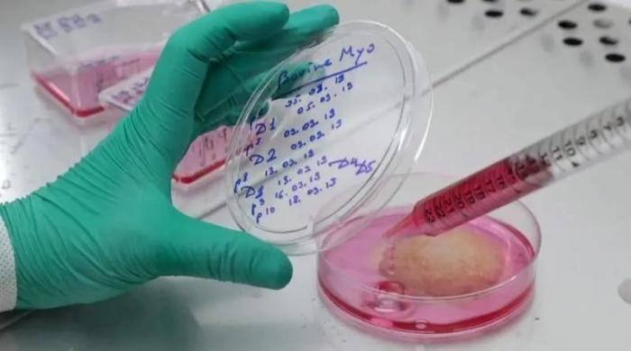Mink skins as an example of mammal animal, it is constituted of three overlaid parts: the hypodermis, the dermis and the epidermis. Different parts are composed by different cells. Specifically, the hypodermis also called the subcutaneous tissue is mostly formed of lipid cells, the dermis is consists of an extracellular matrix (ECM; fibers and glycosaminoglycans) and cells, mostly fibroblasts and immune cells while the epidermis is a stratified squamous epithelium mostly composed of keratinocytes (95%). In mammals, these specialized epithelial cells are organized in four layers (from the most internal to the most external layer): the basal (or stratum germinativum), spinous (or stratum spinosum), granular (or stratum granulosum) and cornified (or stratum corneum) layers. Each layer contains keratinocytes at different stages of differentiation, from basal keratinocytes in the basal layer to corneocytes in the cornified layer. Bio-synthetic fur aims to use iPSCs to generate all cellulars and tissues and combined organically to obtain the desired product.

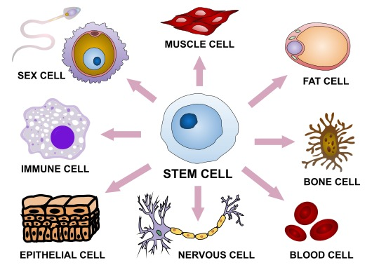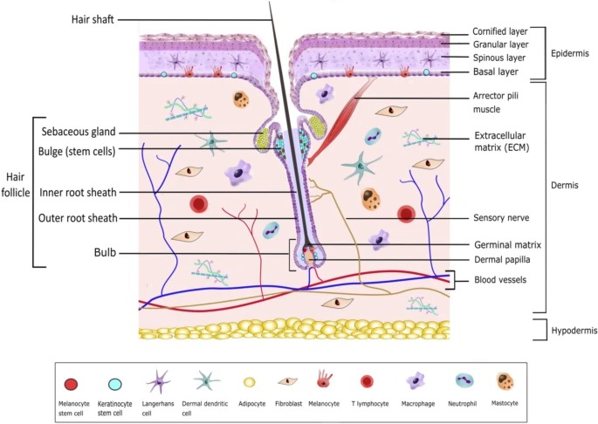Overall, bio-synthetic fur combines technology and practicality, it will be identical to real fur, non-killing and environment-friendly.

**Semi Bio-synthetic Fur**

As a variant of fully bio-synthetic fur, there is no distinction in terms of performance, structure and animal & environmental impact between fully and semi bio-synthetic fur. Semi bio-synthetic fur combines the technology of stem cell transplantation for only the hypodermis and the dermisand and then unique process called woolization to form rest part of fur. Woolization is a concept inspired by wool shearing that collecting hair from those farming animals like mink and fox. Due to those farming animals are mainly mammals, their hair(epithelial cells) will natural shed and replacement, shearing or collecting will not harm the animals. Therefore, the main differences for fully and semi bio-synthetic concentrate on effectiveness and long-run supply chain.

In respect of effectiveness, it has two aspect: difficulty and cost of research and development. Admittedly, stem cell cultivation is theoretically possible for a full range of cells, but the time and cost increases geometrically with the adding number of species. Therefore, woolization significantly saves development time and costs，which eventually offers the possibility of accelerated commercialization.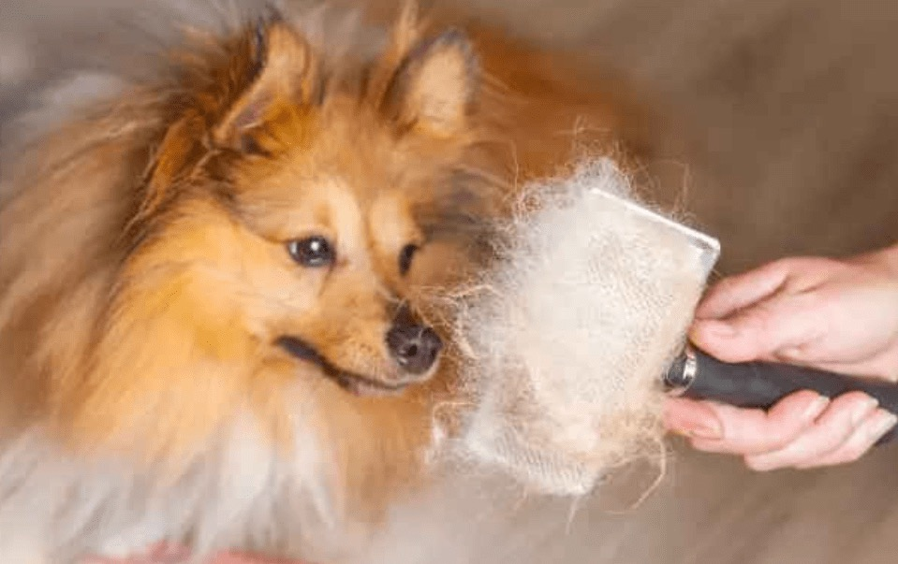

If bio-synthetic fur is successfully developed and put on the market, it must be acknowledged that this will deal a non-negligible attacks to farming animals and employment in the traditional fur industry. With the declining of real fur consumption, there will be the significant surplus for existing farming animal in short-run. Regardless of extermination or stocking, it will all cause a huge disaster in ethics or ecology. Semi bio-synthetic can create new demand for those existing farming animals and the value of those animals has changed from one-time skinning to repeated hair collection. In aspect of employment, semi bio-synthetic fur can digest most labor from old industry because bonding the cortex to the hair is a labor-intensive process.

To conclude, semi bio-synthetic aim to balance between the disruptive effects of cutting-edge technology and the stability of the current industrial structure. Therefore, it is the top priority for whole plan.

# Marketing Plan

## 3.1 Market research

According to Gitnux(2023), global fur sales reached $35.8 billion in 2018. This statistic is a clear indication that the fur industry is still a major player in the fashion industry and is likely to remain so in the future.

In respect of faux fur market, due to the COVID-19 pandemic and Russia-Ukraine War Influence, the global market for Artificial Fur estimated at US$ 176.8 million in the year 2022, is projected to reach a revised size of US$ 388 million by 2028, growing at a CAGR of 14.0% during the forecast period 2022-2028(Industry Research 2023).

Bio-synthetic fur as a innovative product is a good replacement for both genuine and faux fur. As the product is still in the lab stage, it is difficult to say exactly how big the market will be, but given the competition, a conservative estimate is that this is a multi-million dollar and growing market.

## 3.2 Marketing position & Pricing

The market positioning of bio-synthetic fur is divided into 3 stages: Tesla Roadster, Tesla S and Tesla y, which is inspired by different model of Tesla.

**Tesla Roadster**

As the initial stage of the output, bio-synthetic fur will mainly produce in laboratory. Due to the cost and production, It will only be aimed at the segment of customers with the most purchasing power in the world. High technology, low production and high barriers to entry will be the main features of this phase of the product, which will close to the feature of Tesla Roadster. In respect of pricing, due to its scarcity and monopoly status, it is likely to be the most expensive clothing material ever made.

**Tesla Model S**

As the product moves out of the lab and into initial mass production, its market position may change to a fabric of choice for High Net Worth Individuals who interest in high-tech and eco-friendly. The shift of position may be in the form of product models, but the current plan is more towards the establishment of different branch brands. The pricing strategy will similar to Tesla Model S, the end price of bio-synthetic fur will be at the head of the entire textile industry reference to Vicuna wool and Mulberry silk.

**Tesla Model Y**

Following the above logic, bio-synthetic fur will surely eventually be mass produced and its cost and availability will probably sink to the mass market, just as the launch of model Y has done for the Tesla brand. However, the plan to adjust the positioning and pricing of the product at this time will not be discussed too much at this time and will be carried out by the team after the product has been successfully developed.

## 3.3 Target Customer

Based on market position and pricing strategy above, here is the customer template follow:

|  |  |
| --- | --- |
| Demographic | Psychographic |
| Age: 25-40 | Interest: Technology & Eco-friendly Product |
| Location: Developed Country & International City | Hobbies: / |
| Gender: All | Values: Environmentalism & Animalism |
| Income: Top Level | Behaviour: / |
| Education: / | Attitude: Support Technology Innovation |
| Status: Freedom of Wealth | Lifestyle Preference: Promoting technology and eco-friendly living |
| Occupation: / |

3.4 Competitors

**Mansion/0**

This is program cooperated by LVMH and Central Saint Martins are targeting on this and other issues in“regenerative luxury”since 2017. Their Lab-grown fur has 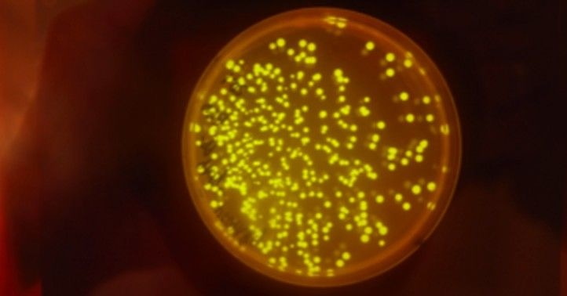successfully produced mink keratin in yeast and is now moving into the second phase of the project: fibre development along with Fendi and Tom Ellis Lab, Imperial College London.

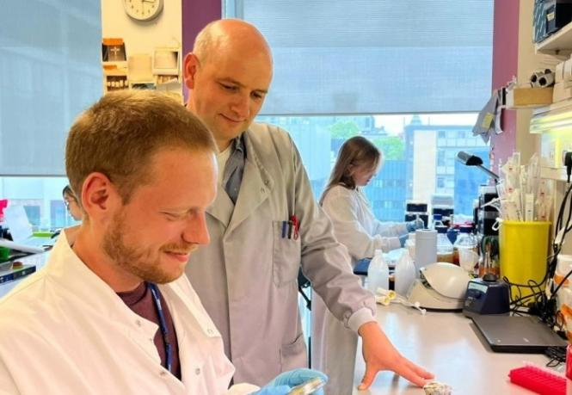As the only potential competitor currently on the market, this project goes one step faster while utilizing a similar methodology as fully bio-synthetic fur. However, besides the advantage of semi bio-synthetic fur comparing with fully bio-synthetic, the biggest advantage for bio-synthetic fur is aggregation. Their research did not achieve aggregation due to multiple collaborations and ambitious goals. Their research also placed more emphasis on the synthesis of more animal hairs(keratin) such as mohair or cashmere, or even a fur coat made from the woolly mammoth genome.

Therefore bio-synthetic fur is a more focused, stronger commercially promising and more relevant project for the current fur industry.

## 3.4 SWOT Analysis

|  |  |
| --- | --- |
| Strengths   1. Unique Project   The world's latest fur technology, potential to disrupt an entire industry.   1. Authority Cooperation   Cooperated with KC LAB at Columbia University, USA.   1. Wide Market   Conservatively it estimates a multi-million dollar and growing market. | Weakness   1. Scarce Production(High Cost)   Laboratory-based product at first stage is unlikely to get down the cost.   1. Difficulties of Commercialization   From laboratory to commercialization, it's a long process like cultured meat.   1. The paradox of sales and profit   Due to the cost of product development, it is difficult to balance market expansion and profit retention. |
| Opportunities   1. Redevelopment of traditional fur industry   Bio-synthetic can lead traditional fur industry into stable transition and rekindle customer interest.   1. New Employment   Semi bio-synthetic fur will be labour-intensive in its infancy, therefore, it can transfer big quantity of old employment to new industry.   1. Technology Innovation   This product is technology based. | Threats   1. Mature Competitor, Mansion/0   A project of the same type that has already started with the association of a fashion giant.   1. Cheap Artificial Material   In a price-driven market, cheap synthetic materials continue to have a large share. |

# Operational Plan

## 4.1 Cooperation

**R&D**

Bio-synthetic fur will be carried out in collaboration with KC LAB, which has received a verbal commitment to participate by Dr. Chandran and has already started implementation for 2-year period estimated. Kartik Chandran is the professor of earth and environment engineering. Chandran’s work is enabled through understanding and harnessing the biochemical potential and metabolism of microbial communities and developing appropriate technologies towards addressing global environmental and societal needs. KC LAB, a renowned bioengineering laboratory at Columbia University, is well placed to ensure the smooth implementation and final output of bio-synthetic fur.

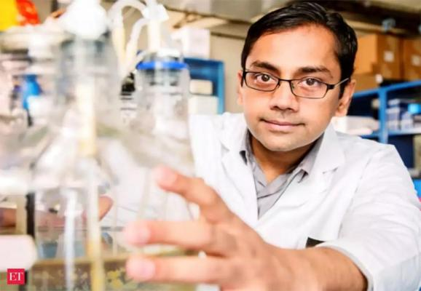**Manufacturing**

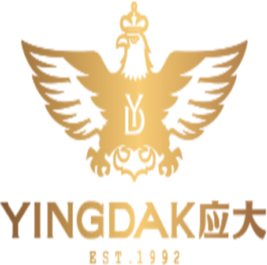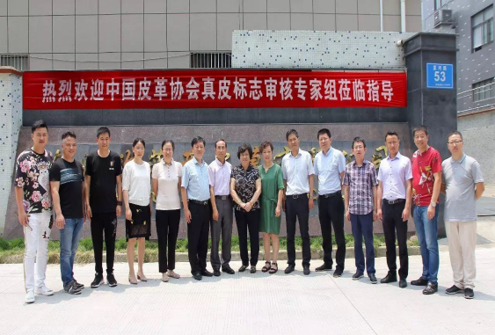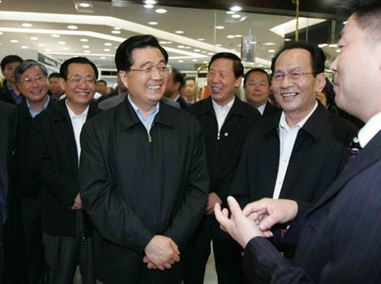OFY LTD as an authorized production base was originally one of the most consistent quality-controlled factories in fur industry over China, with over 25 years of production experience in the fur industry, and is now the designated manufacturer for all online high-end fur brands in China.

The cooperation with OFY also means cooperation with Yingdak Group（sibling enterprise）, the most influential capital in the Beijing-Tianjin-Hebei region. Yingdak Group's involvement behind the project guarantees potential advantages at the government policy level and technical experience support for large-scale production.

## 4.2 Location

The research and development of bio-synthetic fur will mainly based on New York, United Sate(Colombia University).

The commercialization and mass production in the future will set in Ningbo, China, the biggest city for both genuine fur and faux fur manufacturing over the world.

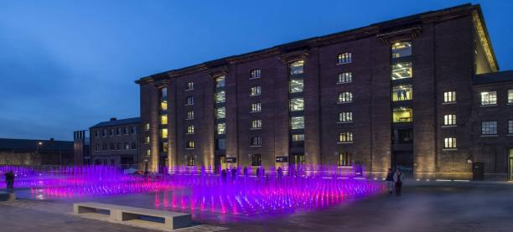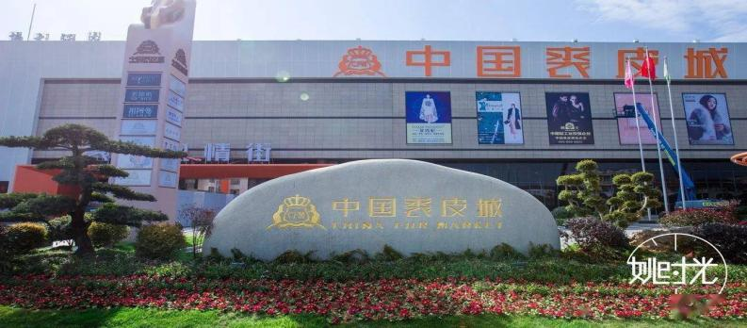The communication centre of whole project is now based in London, United Kingdom， radiating the Europe with the greatest purchasing power for fur market and the most sophisticated fabric technology.

## 4.3 Personnel

Gu, Hongbin

Concept maker, founder of the project and general director of communication. MA of Applied Imagination, Central Saint Martins in progress. Expertise in marketing and organizing. With more than ten years of experience in the fur industry: familiar with all aspects of raw materials, garment production and other operations. Having a clear understanding and absolute control over the progress and outcome of bio-synthetic fur at current stage.

Zhou, Kangzhe

General technical advisor for the project and general manager of the R&D direction. MS/PhD of Earth and Environment Engineering, Columbia University in progress. As the intensive research of bio-technology and environment engineering, Zhou is the main link between the project and KC LAB(Kartik Chandran) and is in charge of the technology-based communication.

Li, Chang

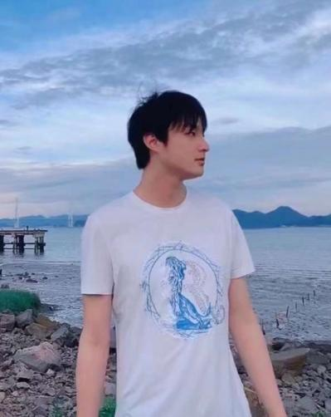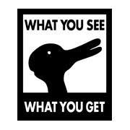Project financial director and strategy advisor. MSc of Finance Economics, Oxford University. Dual college experience in Pennsylvania and Oxford in progress, with professional knowledge in the financial direction. Also a guide at the strategic level of whole project.

# Finance & Commitment

## 5.1 Start-up Cost（R&D）

|  |  |  |  |
| --- | --- | --- | --- |
| Cost Description | Cost($) | Rationale | Tips |
| Project Researcher Salary | $70,000 per year  Projected cycle of 2-3 years with total $210,000 | Approval from KC LAB, funding for exclusive PhD researchers of bio-synthetic fur | Consultation with laboratories on milestone-oriented payments |
| Laboratory Funding | $100,000 for two years | Business partnership start-up funding of KC LAB | Part-covered by project owner |
| Communication Cost | $25,000 annually | Cost of phase communication, verification and advertising | Already fully covered by project owner |
| Total | $350,000 estimated |  |  |

## 5.2 Call for Cooperation & Commitment

**Investor**

For investors, the project is seeking a $250,000 shortfall in funding for R&D phase, meanwhile, it asks for subsequent investment in mass production and other technical collaborations.

In return, this investment releases a 5% income right（mainly including patent revenue and product revenue） and a right of first refusal on subsequent investments.

**Brand**

For the brand, the main needs of the project are channel, promotion and cooperation in the application of materials. Benchmark the strength of the competitor, this partnership will tend to favour the luxury and materials giants.

In return, brands can share the right to use patents and the exclusive 5-year supply guarantee for mass production in the future (commitment to exclusive partnerships with individual brands only).